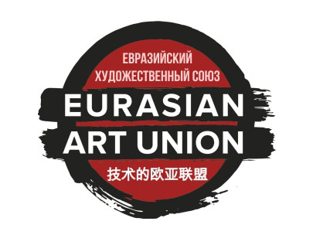 | EURASIAN ART UNION  www.eurasianartunion.com  E-mail: info@artunion.pro  Mobile: +7-925-0537000, ,  Tel./fax: +7 (495) 6407722

BANK DETAILS

To transfer funds in EUR
via Deutsche Bank AG, Frankfurt am Main, Germany
INTERMEDIARY BANK: | DEUTDEFF  DEUTSCHE BANK AG,  FRANKFURT AM MAIN, GERMANY
BANK OF BENEFICIARY: | /100-9477522-00 EUR  SWIFT: JSNMRUMM  “Bank Otkritie Financial Corporation” (Public Joint-Stock Company)  MOSCOW, RUSSIA.
BENEFICIARY: ACCOUNT: | 40703978109000201043
ORGANIZATION’S NAME | Eurasian Art Union
ADDRESS | office "Union of Artists", Krymskiy Val str. 8 / 2, 119049, Moscow, Russia

To transfer funds to CNY
through Bank of China (ELUOSI), Moscow, Russia
INTERMEDIARY BANK: | BKCHRUMM  BANK OF CHINA (ELUOSI),  MOSCOW, RUSSIA
BANK OF BENEFICIARY: | /30109156800000000005  SWIFT: JSNMRUMM  “Bank Otkritie Financial Corporation” (Public Joint-Stock Company)  MOSCOW, RUSSIA.
BENEFICIARY: ACCOUNT: | 40703156109000201043
ORGANIZATION’S NAME | Eurasian Art Union
ADDRESS | office "Union of Artists", Krymskiy Val str. 8 / 2, 119049, Moscow, Russia

To transfer funds in USD
through The Bank of New York Mellon, New York, USA
INTERMEDIARY BANK: | IRVTUS3N  THE BANK OF NEW YORK MELLON,  NEW YORK, USA
BANK OF BENEFICIARY: | /890-0584-157  SWIFT: JSNMRUMM  “Bank Otkritie Financial Corporation” (Public Joint-Stock Company)  MOSCOW, RUSSIA.
BENEFICIARY: ACCOUNT: | 40703840509000201043
ORGANIZATION’S NAME | Eurasian Art Union
ADDRESS | office "Union of Artists", Krymskiy Val str. 8 / 2, 119049, Moscow, Russia

